Design Document Anubhav Panda (panda047) ,Sanjit Dash(dash0030)  
Design of The PA2  
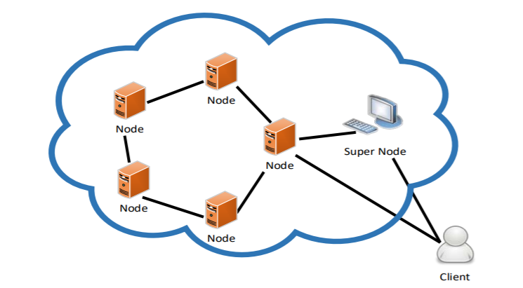

OverView  
In this project we have implemented a chord based DHT system using java and thrift.  
The Design of the PA2 can be divided into following sections.

Client

SuperNode .Thrift(Thrift server responsible for Super node communication)

SuperNodeServerHandler.Java

SuperNodeServer.Java

DHTNode.Thrift(Thrift server responsible for DHT node communication)

DHTNodeServerHandler.Java

DHTNodeServer.Java

**Client.Java:**

The client reads takes the input from the user and based on the input it decides whether to get or set calls to the server.

Initially it calls the getnode method of the super node to get a node from the dht.And based on the node it calls to the Dht for get and set methods.

Initially it sets All data into the DHT.

**Thrift files used for SuperNode communication**

The following are the thrift files that are used for client SuperNode communication .It contains the following methods  
bool Ping() check your calls are reaching to the server or not.

String Join(String Ip,String Port) :This method is called from the nodes who are interested in joining the DHT it takes two parameters ie

Ip:we are using the host name of the interested DHT Node.

Port:The Port in which will be used for its communication

Method Description :It generally stores a map in which it stores the details of the Ip port combination and it also generates a hash and generates a number from the hash and assigns it as the node number .It also stores the ip and port number in an array.it does all the operation using the Synchronizations variable . If the Super Node is busy in join process of another node, it will return a “NACK” to the requesting node.

String PostJoin(String Ip,String Port): After the node is done to join the DHT (also done to distribute the list of nodes to other nodes), it should notify the SuperNode about it. Only after getting this “Done” message, the SuperNode can allow other nodes to join the DHT. This will prevent nodes from getting added concurrently.It also takes the two arguments HostName and port number to match the locking conditions and possibly Deadlocks.

String GetNode(): For sending requests to DHT, the client should know the node information. For this, the client will contact to the SuperNode and it will return node information randomly chosen. The client may contact SuperNode only once when the client is running or every time when the client sends a request for testing purpose.

string find_predecessor(string id,string nodeId ):This metod is used to give the DhtNode its Predecessor When it joins The inputs are the node ip and the id of the DHT node

string find_successor(string id,string nodeId) :

**SuperNodeServerHandler.Java**

This file implements the the Above mentioned Thrift Files and apart from that it has some of its local methods. The below functions are implemented for local use.

String encryptThisString(String input) :This method is used to encrypt the String for example if we want to Encrypt the host name then this function is called and it helps to return a encrypted string using SHA-1 Algorithm.  
  
**SuperNodeServer.Java**

It contains The following methods .

public static void main(String [] args) :The main method where Implementations Starts.

public static void simple(SuperNode.Processor processor) :Its a simple server which is running as tt threaded server

**Thrift files used for DHTNode communication**

The following are the thrift files that are used for client DHTNode communication .It contains the following methods

bool ping():check your calls are reaching to the server or not.

string Set(string Book_title,string Genre) : This method is used to set the book name in the DHT.It finds the suceesor of the book and call the following method to store it

Book_title:Title of the book.

Genre:Genre of the book

string Set_Dictionary(string Book_title,string Genre):This method is used to set the book name in a particular node of DHT

string Book_title :Title of the book

string Genre:Genre of the book

string Get_Dictionary(string Book_title):This method is used to get the book name in a particular node of DHT using the given book name

string Get(string Book_title) :This method is used to set the book name in the DHT.It finds the suceesor of the book and call the above method to Get it.

void UpdateFingerTable(string id,i32 i,string nodeIP):when a node joins,This method is used to update the finger table of the other nodeS

string id:Node id value of the target node

i32 I:Index of the finger table that needs to be updated

string nodeIP:Node ip value that needs to be updated in the finger table

string find_predecessor(string id,string nodeId ):This method is used to find the predecessor of a given method using the network calls   
node id:from which node the predecessor is called

id:searching for the node id

string find_successor(string id,string nodeId)his method is used to find the Successor of a given method using the network calls using contact node internally it calls the find predecessor method

node id:from which node the Successor is called

id:searching for the node id

string get_successor():This method is used to get the sucessor of the given node using the ip

void init_Finger_table(string id,string contactNodeId,string contactNodeIP):This method is used to initialize the finger table of a new node when it joins.  
  
string closest_preceding_finger(string id,string nodeId),:it is used to return the closest preceding finger of the id

void set_predecessor(string val,string ip):it is used to set the predecessor of a given node;

string print_path(string ip,string targetIp):it is used to print the travesrse path

**DHTNodeServerHandler**

This file implements the the Above mentioned Thrift Files and apart from that it has some of its local methods. The below functions are implemented for local use.

String encryptThisString(String input):encrypt the name of the book

void UpdateDHT():this method is used to update the finger table of othernodes with each entry ehen the node enters

void init_Finger_table():this method is used to initialize the finger table

Pair < DHTNode.Client,TTransport> get_client(String ip):this method is used to create the DhtNode client for Dhtnode calls

Pair < SuperNode.Client,TTransport> client(String ip):This method is used to return the client for super node calls